**2.2 Conditional Statements and Comparisons**

* **Description:**Checking if user can afford an apple (with money leftover)

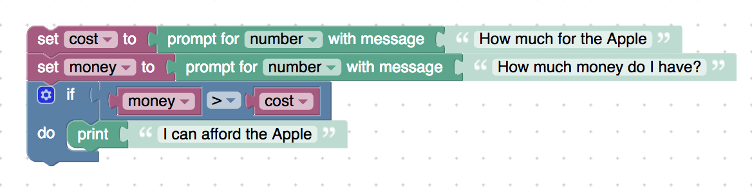

<xml xmlns="http://www.w3.org/1999/xhtml">

 <variables>

    <variable type="" id="KFo-*KBbNB%+#)wTUV_C">cost</variable>

    <variable type="" id="bDEG5^{x8^??1ry3$?[1">money</variable>

 </variables>

 <block type="variables_set" id="so6.zbl;gyUxwKmueU.E" x="112" y="63">

    <field name="VAR" id="KFo-*KBbNB%+#)wTUV_C" variabletype="">cost</field>

    <value name="VALUE">

     <block type="text_prompt_ext" id="-FCM%rduQrxkEYeRe{Fe">

       <mutation type="NUMBER"></mutation>

       <field name="TYPE">NUMBER</field>

       <value name="TEXT">

         <shadow type="text" id="3}1Yy~e/~^421tJQwXi3">

           <field name="TEXT">How much for the Apple</field>

         </shadow>

       </value>

     </block>

    </value>

    <next>

     <block type="variables_set" id="$jmQfVxPW6hx$KE(iLr-">

       <field name="VAR" id="bDEG5^{x8^??1ry3$?[1" variabletype="">money</field>

       <value name="VALUE">

         <block type="text_prompt_ext" id="rV$qh/Fsztj8y:$qJ6~h">

           <mutation type="NUMBER"></mutation>

           <field name="TYPE">NUMBER</field>

           <value name="TEXT">

             <shadow type="text" id="LhN-NDQU|Y$I{Dd?+E0K">

               <field name="TEXT">How much money do I have?</field>

             </shadow>

           </value>

         </block>

       </value>

       <next>

         <block type="controls_if" id="#g)hF5ilw2zsT~KAu57i">

           <value name="IF0">

             <block type="logic_compare" id="WaT3XKhEWw8#C,8$iM2/">

               <field name="OP">GT</field>

               <value name="A">

                 <block type="variables_get" id="^M;|.ReXW{Qk|VB7Qu]p">

                   <field name="VAR" id="bDEG5^{x8^??1ry3$?[1" variabletype="">money</field>

                 </block>

               </value>

               <value name="B">

                 <block type="variables_get" id="r%.zo+UD,WtfOnY!gs{4">

                   <field name="VAR" id="KFo-*KBbNB%+#)wTUV_C" variabletype="">cost</field>

                 </block>

               </value>

             </block>

           </value>

           <statement name="DO0">

             <block type="text_print" id="k$d3sfBiFeYQV`]Y3B6z">

               <value name="TEXT">

                 <shadow type="text" id="tCq#YeEd?$PmibO_Y4^Y">

                   <field name="TEXT">I can afford the Apple</field>

                 </shadow>

               </value>

             </block>

           </statement>

         </block>

       </next>

     </block>

    </next>

 </block>

</xml>

* **Description:** Adding a print statement outside the if block to show that the print statement outside the block will print irrespective of whether the condition is met or not

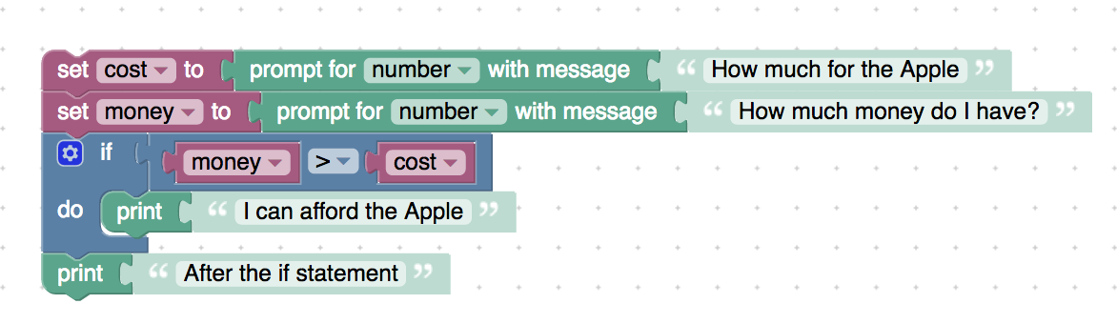

<xml xmlns="http://www.w3.org/1999/xhtml">

 <variables>

    <variable type="" id="KFo-*KBbNB%+#)wTUV_C">cost</variable>

    <variable type="" id="bDEG5^{x8^??1ry3$?[1">money</variable>

 </variables>

 <block type="variables_set" id="so6.zbl;gyUxwKmueU.E" x="112" y="63">

    <field name="VAR" id="KFo-*KBbNB%+#)wTUV_C" variabletype="">cost</field>

    <value name="VALUE">

     <block type="text_prompt_ext" id="-FCM%rduQrxkEYeRe{Fe">

       <mutation type="NUMBER"></mutation>

       <field name="TYPE">NUMBER</field>

       <value name="TEXT">

         <shadow type="text" id="3}1Yy~e/~^421tJQwXi3">

           <field name="TEXT">How much for the Apple</field>

         </shadow>

       </value>

     </block>

    </value>

    <next>

     <block type="variables_set" id="$jmQfVxPW6hx$KE(iLr-">

       <field name="VAR" id="bDEG5^{x8^??1ry3$?[1" variabletype="">money</field>

       <value name="VALUE">

         <block type="text_prompt_ext" id="rV$qh/Fsztj8y:$qJ6~h">

           <mutation type="NUMBER"></mutation>

           <field name="TYPE">NUMBER</field>

           <value name="TEXT">

             <shadow type="text" id="LhN-NDQU|Y$I{Dd?+E0K">

               <field name="TEXT">How much money do I have?</field>

             </shadow>

           </value>

         </block>

       </value>

       <next>

         <block type="controls_if" id="#g)hF5ilw2zsT~KAu57i">

           <value name="IF0">

             <block type="logic_compare" id="WaT3XKhEWw8#C,8$iM2/">

               <field name="OP">GT</field>

               <value name="A">

                 <block type="variables_get" id="^M;|.ReXW{Qk|VB7Qu]p">

                   <field name="VAR" id="bDEG5^{x8^??1ry3$?[1" variabletype="">money</field>

                 </block>

               </value>

               <value name="B">

                 <block type="variables_get" id="r%.zo+UD,WtfOnY!gs{4">

                   <field name="VAR" id="KFo-*KBbNB%+#)wTUV_C" variabletype="">cost</field>

                 </block>

               </value>

             </block>

           </value>

           <statement name="DO0">

             <block type="text_print" id="k$d3sfBiFeYQV`]Y3B6z">

               <value name="TEXT">

                 <shadow type="text" id="tCq#YeEd?$PmibO_Y4^Y">

                   <field name="TEXT">I can afford the Apple</field>

                 </shadow>

               </value>

             </block>

           </statement>

           <next>

             <block type="text_print" id="p[)(gjb)LT:Kcgg35EhP">

               <value name="TEXT">

                 <shadow type="text" id="d,k]mMjQSM~y~@GkQgB2">

                   <field name="TEXT">After the if statement</field>

                 </shadow>

               </value>

             </block>

           </next>

         </block>

       </next>

     </block>

    </next>

 </block>

</xml>

* **Description:** Multiple if statements example

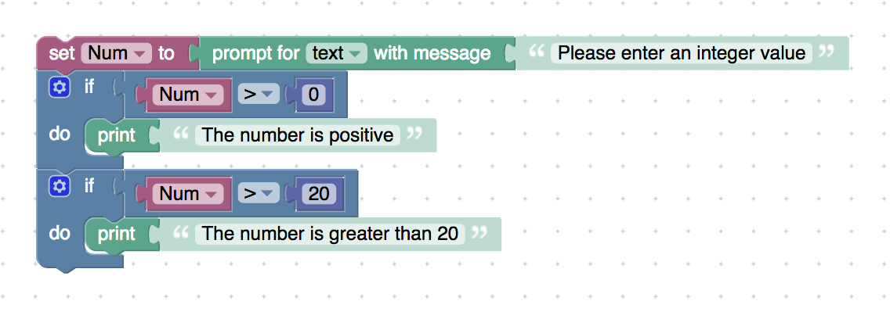

<xml xmlns="http://www.w3.org/1999/xhtml">

 <variables>

    <variable type="" id="@c@zy/%BL//|*y|_I0J1">Num</variable>

 </variables>

 <block type="variables_set" id="6i]nO]O4/RcTmll~Z1#p" x="338" y="163">

    <field name="VAR" id="@c@zy/%BL//|*y|_I0J1" variabletype="">Num</field>

    <value name="VALUE">

     <block type="text_prompt_ext" id="98`iNpl(ee$6ZgaYm*a^">

       <mutation type="TEXT"></mutation>

       <field name="TYPE">TEXT</field>

       <value name="TEXT">

         <shadow type="text" id=")O(X2rYW8TA[@1my9+VO">

           <field name="TEXT">Please enter an integer value</field>

         </shadow>

       </value>

     </block>

    </value>

    <next>

     <block type="controls_if" id="L]_/rstS0Ja,?se+;`[#">

       <value name="IF0">

         <block type="logic_compare" id="v:%NwpO{A6T2;pmil^Xe">

           <field name="OP">GT</field>

           <value name="A">

             <block type="variables_get" id="VS0F)36U^*aC{,eU!ID=">

               <field name="VAR" id="@c@zy/%BL//|*y|_I0J1" variabletype="">Num</field>

             </block>

           </value>

           <value name="B">

             <block type="math_number" id="13KXUCcTgR_-N7NGSI*=">

               <field name="NUM">0</field>

             </block>

           </value>

         </block>

       </value>

       <statement name="DO0">

         <block type="text_print" id="$dLVf9eRceYRc^He$)D`">

           <value name="TEXT">

             <shadow type="text" id="vnq$x|B91ZKEqfIW^h,^">

               <field name="TEXT">The number is positive</field>

             </shadow>

           </value>

         </block>

       </statement>

       <next>

         <block type="controls_if" id="uRzfrW4*4z@qgg,4I(,m">

           <value name="IF0">

             <block type="logic_compare" id="Z-0YQh,CFNqOcVF}zE_]">

               <field name="OP">GT</field>

               <value name="A">

                 <block type="variables_get" id="#6#S{WTKbRH6n/UXPj%t">

                   <field name="VAR" id="@c@zy/%BL//|*y|_I0J1" variabletype="">Num</field>

                 </block>

               </value>

               <value name="B">

                 <block type="math_number" id="vq{m=-pjY#z:xozIrQDJ">

                   <field name="NUM">20</field>

                 </block>

               </value>

             </block>

           </value>

           <statement name="DO0">

             <block type="text_print" id="O%b3OFab{5m5[1Ra?,Xn">

               <value name="TEXT">

                 <shadow type="text" id="_(ZDz*qX]c+UM/%K-#t/">

                   <field name="TEXT">The number is greater than 20</field>

                 </shadow>

               </value>

             </block>

           </statement>

         </block>

       </next>

     </block>

    </next>

 </block>

</xml>

* **Description:** If-else example (checking if number is positive)

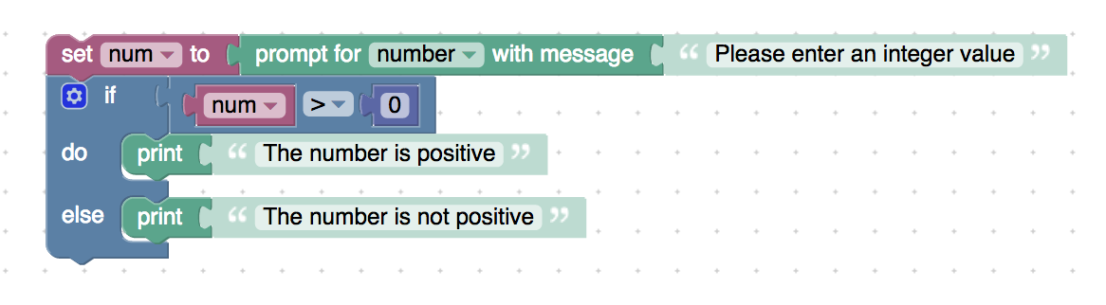

<xml xmlns="http://www.w3.org/1999/xhtml">

 <variables>

    <variable type="" id="P]f{v4d}v{Cn:,hEzMV?">num</variable>

 </variables>

 <block type="variables_set" id="lr5Yl{D2W6`a]p3^~P!r" x="138" y="38">

    <field name="VAR" id="P]f{v4d}v{Cn:,hEzMV?" variabletype="">num</field>

    <value name="VALUE">

     <block type="text_prompt_ext" id="V2e:XPv`lNpIuDo8,w(^">

       <mutation type="NUMBER"></mutation>

       <field name="TYPE">NUMBER</field>

       <value name="TEXT">

         <shadow type="text" id="=;lZ1$j~C62d4C2geY!5">

           <field name="TEXT">Please enter an integer value</field>

         </shadow>

       </value>

     </block>

    </value>

    <next>

     <block type="controls_if" id="@x7`%#q#`c$JZ~~bOp:L">

       <mutation else="1"></mutation>

       <value name="IF0">

         <block type="logic_compare" id="^]70SJf..^Gl(l7O5OUf">

           <field name="OP">GT</field>

           <value name="A">

             <block type="variables_get" id="ah#H$`=ddrTaG,)5u.;{">

               <field name="VAR" id="P]f{v4d}v{Cn:,hEzMV?" variabletype="">num</field>

             </block>

           </value>

           <value name="B">

             <block type="math_number" id="%NIjgZ#b=aqAMLxnn-?y">

               <field name="NUM">0</field>

             </block>

           </value>

         </block>

       </value>

       <statement name="DO0">

         <block type="text_print" id="+Wi$aP+IiGei#7@v0KD2">

           <value name="TEXT">

             <shadow type="text" id="-pS1:k|QnvHUgbuWCMN-">

               <field name="TEXT">The number is positive</field>

             </shadow>

           </value>

         </block>

       </statement>

       <statement name="ELSE">

         <block type="text_print" id="@lpV[`-i`zo;I07R[ISF">

           <value name="TEXT">

             <shadow type="text" id=")=-%F23_8`Ks_w]*zR)n">

               <field name="TEXT">The number is not positive</field>

             </shadow>

           </value>

         </block>

       </statement>

     </block>

    </next>

 </block>

</xml>

* **Nested-if example**

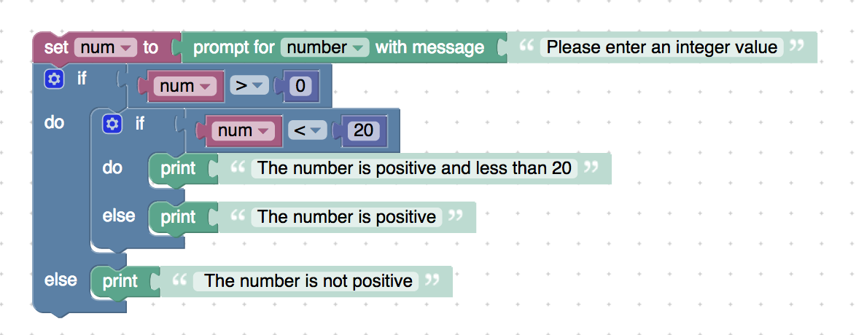

<xml xmlns="http://www.w3.org/1999/xhtml">

 <variables>

    <variable type="" id="P]f{v4d}v{Cn:,hEzMV?">num</variable>

 </variables>

 <block type="variables_set" id="lr5Yl{D2W6`a]p3^~P!r" x="138" y="38">

    <field name="VAR" id="P]f{v4d}v{Cn:,hEzMV?" variabletype="">num</field>

    <value name="VALUE">

     <block type="text_prompt_ext" id="V2e:XPv`lNpIuDo8,w(^">

       <mutation type="NUMBER"></mutation>

       <field name="TYPE">NUMBER</field>

       <value name="TEXT">

         <shadow type="text" id="=;lZ1$j~C62d4C2geY!5">

           <field name="TEXT">Please enter an integer value</field>

         </shadow>

       </value>

     </block>

    </value>

    <next>

     <block type="controls_if" id="@x7`%#q#`c$JZ~~bOp:L">

       <mutation else="1"></mutation>

       <value name="IF0">

         <block type="logic_compare" id="^]70SJf..^Gl(l7O5OUf">

           <field name="OP">GT</field>

           <value name="A">

             <block type="variables_get" id="ah#H$`=ddrTaG,)5u.;{">

               <field name="VAR" id="P]f{v4d}v{Cn:,hEzMV?" variabletype="">num</field>

             </block>

           </value>

           <value name="B">

             <block type="math_number" id="%NIjgZ#b=aqAMLxnn-?y">

               <field name="NUM">0</field>

             </block>

           </value>

         </block>

       </value>

       <statement name="DO0">

         <block type="controls_if" id="Fo0HO[~79+4F)OffP*Hz">

           <mutation else="1"></mutation>

           <value name="IF0">

             <block type="logic_compare" id="sLfg=-HcDXP)s{Z2Wabm">

               <field name="OP">LT</field>

               <value name="A">

                 <block type="variables_get" id="Mm}wby-maR-o=Q3mT9@,">

                   <field name="VAR" id="P]f{v4d}v{Cn:,hEzMV?" variabletype="">num</field>

                 </block>

               </value>

               <value name="B">

                 <block type="math_number" id="zHJ_n(X+}9it;R[tE]I_">

                   <field name="NUM">20</field>

                 </block>

               </value>

             </block>

           </value>

           <statement name="DO0">

             <block type="text_print" id="+Wi$aP+IiGei#7@v0KD2">

               <value name="TEXT">

                 <shadow type="text" id="-pS1:k|QnvHUgbuWCMN-">

                   <field name="TEXT">The number is positive and less than 20</field>

                 </shadow>

               </value>

             </block>

           </statement>

           <statement name="ELSE">

             <block type="text_print" id="@lpV[`-i`zo;I07R[ISF">

               <value name="TEXT">

                 <shadow type="text" id=")=-%F23_8`Ks_w]*zR)n">

                   <field name="TEXT">The number is positive</field>

                 </shadow>

               </value>

             </block>

           </statement>

         </block>

       </statement>

       <statement name="ELSE">

         <block type="text_print" id="s$A{%L%6m_aV2xnCrznH">

           <value name="TEXT">

             <shadow type="text" id="POxbCXL.8xFruoNZoV/c">

               <field name="TEXT"> The number is not positive</field>

             </shadow>

           </value>

         </block>

       </statement>

     </block>

    </next>

 </block>

</xml>

**Description:** Checking whether a number is in a range of numbers (exclusive)

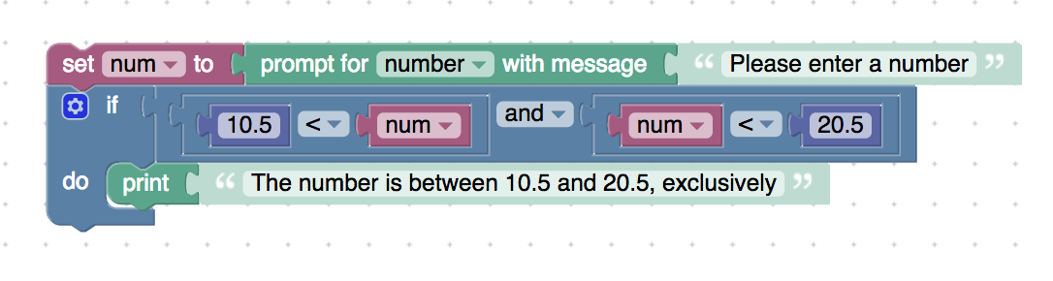

<xml xmlns="http://www.w3.org/1999/xhtml">

 <variables>

    <variable type="" id="NpH/cJp#NFU-AHV/:d|p">num</variable>

 </variables>

 <block type="variables_set" id="-{bwLYcsld`OOe*nI:wr" x="213" y="-62">

    <field name="VAR" id="NpH/cJp#NFU-AHV/:d|p" variabletype="">num</field>

    <value name="VALUE">

     <block type="text_prompt_ext" id="/Dw]m,{sN)r{AJF,]~=U">

       <mutation type="NUMBER"></mutation>

       <field name="TYPE">NUMBER</field>

       <value name="TEXT">

         <shadow type="text" id=".GMvx?LL`a|fmeg[Y=B_">

           <field name="TEXT">Please enter a number</field>

         </shadow>

       </value>

     </block>

    </value>

    <next>

     <block type="controls_if" id="-x)_YJWg.CuZw}k5=pAr">

       <value name="IF0">

         <block type="logic_operation" id=":w=RO7PK*yHr+}P`5n*V">

           <field name="OP">AND</field>

           <value name="A">

             <block type="logic_compare" id="~`}*)*][,1f`M=CfCDFp">

               <field name="OP">LT</field>

               <value name="A">

                 <block type="math_number" id="gVp1od{[6V,zgTW0RFmn">

                   <field name="NUM">10.5</field>

                 </block>

               </value>

               <value name="B">

                 <block type="variables_get" id="LwQ]]g0,,A:LN9|5,=},">

                   <field name="VAR" id="NpH/cJp#NFU-AHV/:d|p" variabletype="">num</field>

                 </block>

               </value>

             </block>

           </value>

           <value name="B">

             <block type="logic_compare" id="9=x:Xz75Jz8_id:gkO?s">

               <field name="OP">LT</field>

               <value name="A">

                 <block type="variables_get" id="6VPmh:#JYKDYf1m|R9TG">

                   <field name="VAR" id="NpH/cJp#NFU-AHV/:d|p" variabletype="">num</field>

                 </block>

               </value>

               <value name="B">

                 <block type="math_number" id="F~}2Hm9]df:Ww8u^pFiD">

                   <field name="NUM">20.5</field>

                 </block>

               </value>

             </block>

           </value>

         </block>

       </value>

       <statement name="DO0">

         <block type="text_print" id="SeS#`C}!yQ=/?J8b}}nH">

           <value name="TEXT">

             <shadow type="text" id=";H9-URCo{y5|z%HCd+w?">

               <field name="TEXT">The number is between 10.5 and 20.5, exclusively</field>

             </shadow>

           </value>

         </block>

       </statement>

     </block>

    </next>

 </block>

</xml>

* **Description:** Checking whether a number is in a range of numbers (inclusive example)

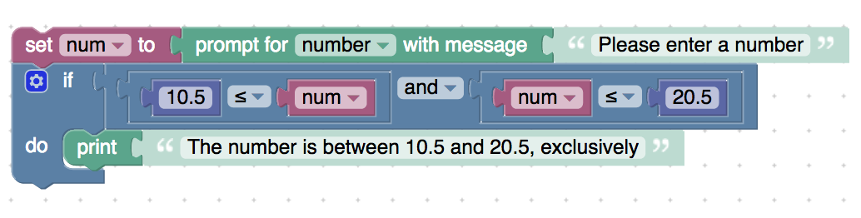

<xml xmlns="http://www.w3.org/1999/xhtml">

 <variables>

    <variable type="" id="NpH/cJp#NFU-AHV/:d|p">num</variable>

 </variables>

 <block type="variables_set" id="-{bwLYcsld`OOe*nI:wr" x="213" y="-62">

    <field name="VAR" id="NpH/cJp#NFU-AHV/:d|p" variabletype="">num</field>

    <value name="VALUE">

     <block type="text_prompt_ext" id="/Dw]m,{sN)r{AJF,]~=U">

       <mutation type="NUMBER"></mutation>

       <field name="TYPE">NUMBER</field>

       <value name="TEXT">

         <shadow type="text" id=".GMvx?LL`a|fmeg[Y=B_">

           <field name="TEXT">Please enter a number</field>

         </shadow>

       </value>

     </block>

    </value>

    <next>

     <block type="controls_if" id="-x)_YJWg.CuZw}k5=pAr">

       <value name="IF0">

         <block type="logic_operation" id=":w=RO7PK*yHr+}P`5n*V">

           <field name="OP">AND</field>

           <value name="A">

             <block type="logic_compare" id="~`}*)*][,1f`M=CfCDFp">

               <field name="OP">LTE</field>

               <value name="A">

                 <block type="math_number" id="gVp1od{[6V,zgTW0RFmn">

                   <field name="NUM">10.5</field>

                 </block>

               </value>

               <value name="B">

                 <block type="variables_get" id="LwQ]]g0,,A:LN9|5,=},">

                   <field name="VAR" id="NpH/cJp#NFU-AHV/:d|p" variabletype="">num</field>

                 </block>

               </value>

             </block>

           </value>

           <value name="B">

             <block type="logic_compare" id="9=x:Xz75Jz8_id:gkO?s">

               <field name="OP">LTE</field>

               <value name="A">

                 <block type="variables_get" id="6VPmh:#JYKDYf1m|R9TG">

                   <field name="VAR" id="NpH/cJp#NFU-AHV/:d|p" variabletype="">num</field>

                 </block>

               </value>

               <value name="B">

                 <block type="math_number" id="F~}2Hm9]df:Ww8u^pFiD">

                   <field name="NUM">20.5</field>

                 </block>

               </value>

             </block>

           </value>

         </block>

       </value>

       <statement name="DO0">

         <block type="text_print" id="SeS#`C}!yQ=/?J8b}}nH">

           <value name="TEXT">

             <shadow type="text" id=";H9-URCo{y5|z%HCd+w?">

               <field name="TEXT">The number is between 10.5 and 20.5, exclusively</field>

             </shadow>

           </value>

         </block>

       </statement>

     </block>

    </next>

 </block>

</xml>

**Description:** Checking whether the temperature is cold, warm or hot using if statements

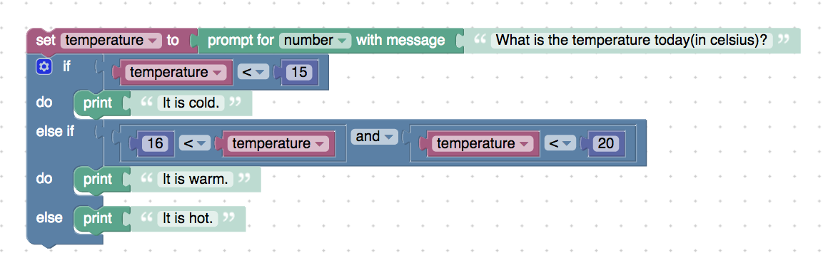

<xml xmlns="http://www.w3.org/1999/xhtml">

 <variables>

    <variable type="" id="c${:D]gvL0/z~UtMc,^U">temperature</variable>

 </variables>

 <block type="variables_set" id="weuo~Hz#9rTH*K.dAU81" x="387" y="-112">

    <field name="VAR" id="c${:D]gvL0/z~UtMc,^U" variabletype="">temperature</field>

    <value name="VALUE">

     <block type="text_prompt_ext" id="`.=^:IK4xa,~r*Odl$E7">

       <mutation type="NUMBER"></mutation>

       <field name="TYPE">NUMBER</field>

       <value name="TEXT">

         <shadow type="text" id="n=3Vvd%=6[tJjIdZt2*L">

           <field name="TEXT">What is the temperature today(in celsius)?</field>

         </shadow>

       </value>

     </block>

    </value>

    <next>

     <block type="controls_if" id="dE892zK7R_y-6T1)OJQ_">

       <mutation elseif="1" else="1"></mutation>

       <value name="IF0">

         <block type="logic_compare" id="c;,Smzr_M?Tq7r.wfDc;">

           <field name="OP">LT</field>

           <value name="A">

             <block type="variables_get" id="!S}1rF.]Iu~EFHoF:FhR">

               <field name="VAR" id="c${:D]gvL0/z~UtMc,^U" variabletype="">temperature</field>

             </block>

           </value>

           <value name="B">

             <block type="math_number" id="4IVKjV9(9FbH:Zv#$/kQ">

               <field name="NUM">15</field>

             </block>

           </value>

         </block>

       </value>

       <statement name="DO0">

         <block type="text_print" id="j3JiJgm,4P6E1^_*3m=v">

           <value name="TEXT">

             <shadow type="text" id="/C!XscV$y_QW=;(,D.~k">

               <field name="TEXT">It is cold.</field>

             </shadow>

           </value>

         </block>

       </statement>

       <value name="IF1">

         <block type="logic_operation" id="DBs3$c9o-yQ?mZ@ZOQ@W">

           <field name="OP">AND</field>

           <value name="A">

             <block type="logic_compare" id="nt`L20`gk!OJ/}x7:lUy">

               <field name="OP">LT</field>

               <value name="A">

                 <block type="math_number" id="y]L%,5zSQhqnLH;`OUPz">

                   <field name="NUM">16</field>

                 </block>

               </value>

               <value name="B">

                 <block type="variables_get" id="()hQ~U,2a)!KVpb_^Ct.">

                   <field name="VAR" id="c${:D]gvL0/z~UtMc,^U" variabletype="">temperature</field>

                 </block>

               </value>

             </block>

           </value>

           <value name="B">

             <block type="logic_compare" id="@1V0Mgl@S#ivEb!XVY`7">

               <field name="OP">LT</field>

               <value name="A">

                 <block type="variables_get" id="mt02qL|Y$,|F,)$rjEkb">

                   <field name="VAR" id="c${:D]gvL0/z~UtMc,^U" variabletype="">temperature</field>

                 </block>

               </value>

               <value name="B">

                 <block type="math_number" id="Y:{%,y:[0/9_,AS+Tv[M">

                   <field name="NUM">20</field>

                 </block>

               </value>

             </block>

           </value>

         </block>

       </value>

       <statement name="DO1">

         <block type="text_print" id="-v=|::-ZSiKg3JV4u}:o">

           <value name="TEXT">

             <shadow type="text" id="KCe|2#{x%y}t)kZcFfxL">

               <field name="TEXT">It is warm.</field>

             </shadow>

           </value>

         </block>

       </statement>

       <statement name="ELSE">

         <block type="text_print" id="C%tn)eV:D`r0uSSF}|SM">

           <value name="TEXT">

             <shadow type="text" id=",T~U?Ud@=`2ca5pS6a`Z">

               <field name="TEXT">It is hot.</field>

             </shadow>

           </value>

         </block>

       </statement>

     </block>

    </next>

 </block>

</xml>

**Description:** Using boolean variables with if statements

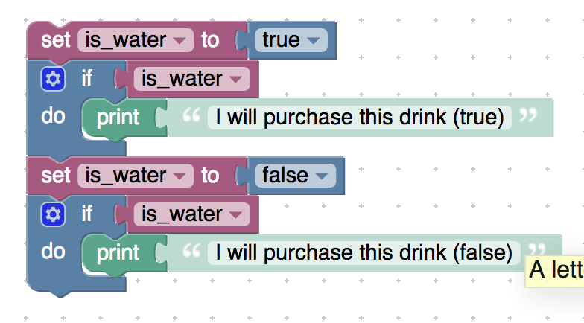

<xml xmlns="http://www.w3.org/1999/xhtml">

 <variables>

    <variable type="" id=";:-M~dqvU)r69-NCrY6P">is_water</variable>

 </variables>

 <block type="variables_set" id="$R{-|Nop~)uFk9xG$@YD" x="113" y="-12">

    <field name="VAR" id=";:-M~dqvU)r69-NCrY6P" variabletype="">is_water</field>

    <value name="VALUE">

     <block type="logic_boolean" id="[J}G$$3f~TlJcw_u|%D;">

       <field name="BOOL">TRUE</field>

     </block>

    </value>

    <next>

     <block type="controls_if" id="8BB@Crx:uWttdH!})|qq">

       <value name="IF0">

         <block type="variables_get" id="/t(U=}]rzqM{b(?nOk)3">

           <field name="VAR" id=";:-M~dqvU)r69-NCrY6P" variabletype="">is_water</field>

         </block>

       </value>

       <statement name="DO0">

         <block type="text_print" id="7:c%Jod|Q/_3@aw(1tPE">

           <value name="TEXT">

             <shadow type="text" id="2dA3JBufl}wmAfOD[xT-">

               <field name="TEXT">I will purchase this drink (true)</field>

             </shadow>

           </value>

         </block>

       </statement>

       <next>

         <block type="variables_set" id="h83!t{9qi6D$4x@jB0NJ">

           <field name="VAR" id=";:-M~dqvU)r69-NCrY6P" variabletype="">is_water</field>

           <value name="VALUE">

             <block type="logic_boolean" id="x5D3.{,q/V_0fe)Y-Wh;">

               <field name="BOOL">FALSE</field>

             </block>

           </value>

           <next>

             <block type="controls_if" id="p%Nq1HCs[Il+si(5uQSm">

               <value name="IF0">

                 <block type="variables_get" id="jx:VU6VVnq%6GF7D3y!?">

                   <field name="VAR" id=";:-M~dqvU)r69-NCrY6P" variabletype="">is_water</field>

                 </block>

               </value>

               <statement name="DO0">

                 <block type="text_print" id="[kQ*5pT)V]T=BIDL?:M^">

                   <value name="TEXT">

                     <shadow type="text" id="/:UA73q?)K8Jhw14drOA">

                       <field name="TEXT">I will purchase this drink (false)</field>

                     </shadow>

                   </value>

                 </block>

               </statement>

             </block>

           </next>

         </block>

       </next>

     </block>

    </next>

 </block>

</xml>

**Description:** Using a boolean variable with if blocks

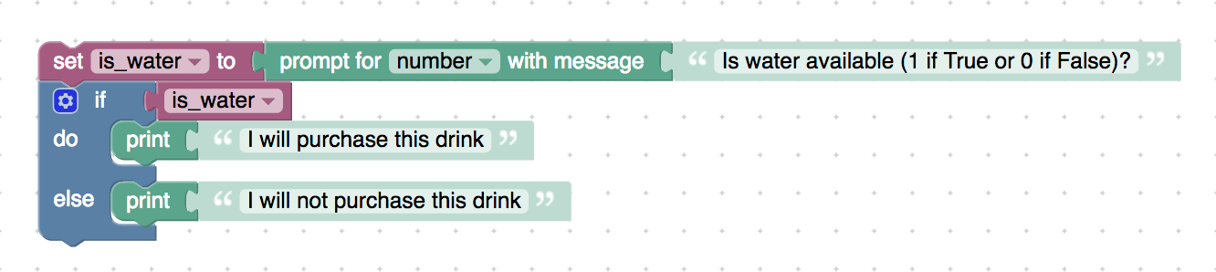

<xml xmlns="http://www.w3.org/1999/xhtml">

 <variables>

    <variable type="" id="#9^H~En8X1lCky7[Dhc5">is_water</variable>

 </variables>

 <block type="variables_set" id="QwMck!bz42NQwzWz+s71" x="113" y="38">

    <field name="VAR" id="#9^H~En8X1lCky7[Dhc5" variabletype="">is_water</field>

    <value name="VALUE">

     <block type="text_prompt_ext" id="}.~zcouI2pfl2qgU6F(O">

       <mutation type="NUMBER"></mutation>

       <field name="TYPE">NUMBER</field>

       <value name="TEXT">

         <shadow type="text" id="o9i/+]eGQ8e!8Jq,G#Pm">

           <field name="TEXT">Is water available (1 if True or 0 if False)?</field>

         </shadow>

       </value>

     </block>

    </value>

    <next>

     <block type="controls_if" id="T(v=M8YIzAKh-]`,8yW3">

       <mutation else="1"></mutation>

       <value name="IF0">

         <block type="variables_get" id="qbxvN#H*sm=bYG7t7ofR">

           <field name="VAR" id="#9^H~En8X1lCky7[Dhc5" variabletype="">is_water</field>

         </block>

       </value>

       <statement name="DO0">

         <block type="text_print" id="LLl5U=Tjlih#6j*0FPXU">

           <value name="TEXT">

             <shadow type="text" id="|*F*Z6+9Jv-#O{~IcZ9/">

               <field name="TEXT">I will purchase this drink</field>

             </shadow>

           </value>

         </block>

       </statement>

       <statement name="ELSE">

         <block type="text_print" id="~b?Sm_J0Y8lh_CX_F4J7">

           <value name="TEXT">

             <shadow type="text" id="Yo|qHGt4a,Fp@z65}Bta">

               <field name="TEXT">I will not purchase this drink</field>

             </shadow>

           </value>

         </block>

       </statement>

     </block>

    </next>

 </block>

</xml>